**Decoding Lair East Labs: A Blueprint for Future Investment Decisions *Key Statistics:***

- Total Number of Startups in the Aggregated Pitch List (Updated 9/1/23): 1119 (22 repeats) - Number of Companies with Total Funding Info Not Found: 315/1097 - Number of Companies with Funding Stage Info Not Found: 166/1097 - Number of Total ‘Failures’ (Either Funding or Funding Stage Info Not Found): 321/1097 - Number of startups w/ funding greater than $2M when pitched (filtered out): 143/1097

**FIGURES BELOW**

**Figure 1**

*Funding Raised by Companies from the Aggregated Pitch List*

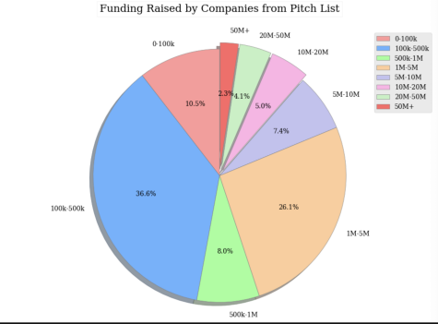

**Figure 2**

*The Funding Stage at which Startups from the Pitch List are Now Present Day*

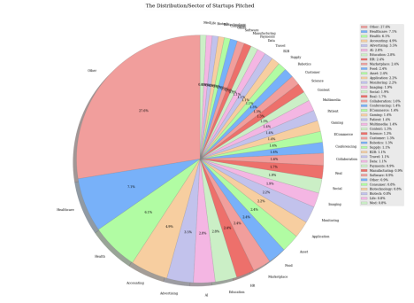

**Figure 3**

*The Multiple of Startups on the Pitch List between when Originally Pitched and Present Da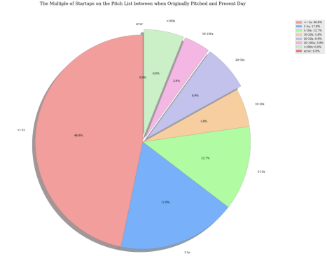*

**Figure 4**

*Average Total Raised by Ranking Levels (Left bar: Without Outliers; Right bar: With Outliers)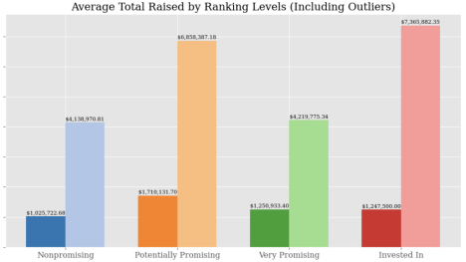*

**Figure 5**

*Violin Plot Showing Distribution of Funding by Ranking Category (Outliers Removed)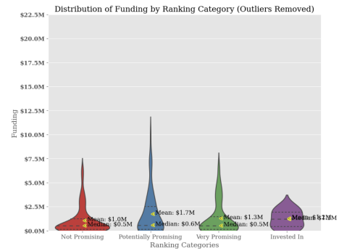*

**Figure 6**

*When looking at Startups Pitched that LEL didn’t invest in, dubbed as “Missed Investments,” here is the breakdown of what ranking LEL gave on average. 0 indicates not promising, 1 indicates potentially promising (yellow highlight), and 2 indicates very promising (green highlight).*

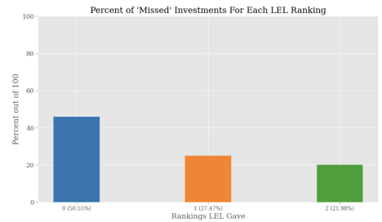

**Figure 7**

*The number of missed investments, separated by LEL ranking.*

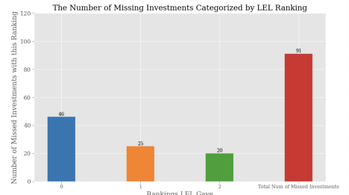

**Figure 8**

*Percent of Startups considered, separated by their LEL Ranking, that did well enough to be considered a “Missed Investment.”*

